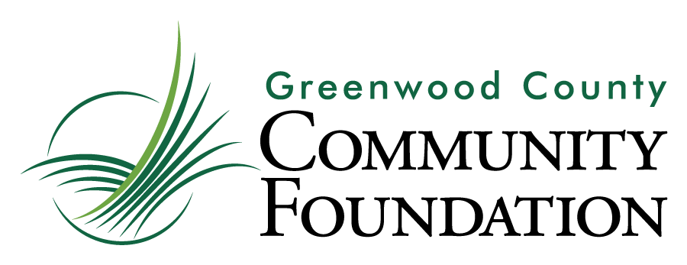

Grant Application

This is a Word Document; should you need additional space to complete a question, you may expand the appropriate text box to meet your needs. Please contact the Foundation at 864.229.2143 or staff@greenwoodcf.org with any questions.

Contact Information
Organization’s Legal Name
Executive Director’s Name
Email Address
Office Phone
Program Coordinator’s Name
Email Address
Office Phone
Organization’s Street Address
City ST ZIP Code
(If different) Mailing Address
City ST ZIP Code
EIN (Fed Tax ID Number)

Summary: Amount of the Grant Requested, Purpose of the Grant Requested
Note requested amount; describe in a sentence or two the program to which the grant will be applied; is this a new or existing program?

Before continuing, you may wish to confirm with the Foundation that your proposal fits appropriately within our granting guidelines. (864.229.2143, staff@greenwoodcf.org)

The Program for which you are requesting funding:
Describe the problem or opportunity the Program addresses.
What steps has your organization taken to assess the population affected by the problem or opportunity? How many people in Greenwood County are affected by this problem/opportunity?
Summarize the program’s overall plan of activity to address the problem or opportunity.
How is this program related to Greenwood County Community Foundation’s focus for this grant cycle?
What other organizations or programs in Greenwood County address this problem or opportunity?
How has your organization collaborated with these organizations?
Identify the outcomes the organization is committed to achieving this year with this program.
What measures will be used to demonstrate the impact of this program on the population served?

Attach the following (may be sent as attached files to staff@greenwoodcf.org):
__ Organizational budget
__ Program or project budget (Please specify how GCCF grant would be used, and include other
anticipated sources of funding for this program or project)
__ Most recent financial statement
__ Proof of IRS tax-exempt status dated within the past five years
__ Non-discrimination statement adopted by the Board of Directors
__ Annual Report if available

The Organization requesting funding:
What is the Mission Statement of your organization?
Please provide a history of your organization’s work in Greenwood County.
List the names (and affiliations) of all members currently on the organization’s Board of Directors.
Please describe all current programs and services of the organization.
The following three questions are to assist the Foundation in its service to local organizations and do not weigh into the grant evaluation process.

Do your Board and staff reflect the demographic of Greenwood County?
Does the organization have an endowment? What is your strategy for long-term funding?
In what ways (in addition to direct monetary assistance) might the Greenwood County Community Foundation serve to strengthen the work of your organization?

Agreement and Signature
By submitting this application, I affirm that the facts set forth in it are true and complete.
Name (printed)
Signature
Date

Thank you for your grant application submission!
Greenwood County Community Foundation
929 Phoenix Street, Suite 16
Greenwood, SC 29646
864.223.1524
Contact: staff@greenwoodcf.org

